**Team Name: _____________________ Section: _______________**

**Members Present (full names printed):**

1. ____________________
2. ____________________
3. ____________________
4. ____________________

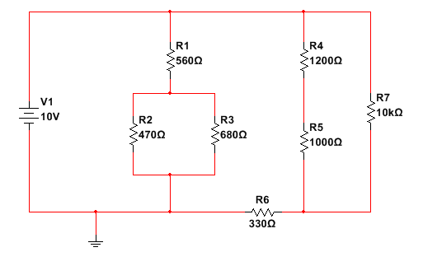

**Find:**

1. The total resistance seen by the source
2. The current through R3 (magnitude AND direction)

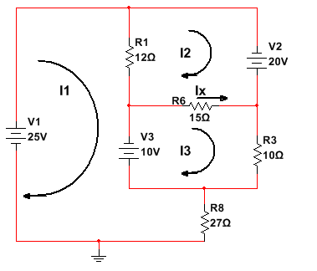

**Given that:**

**I1 = 1.43 A**

**I2 = 1.73 A**

**I3 = 0.639 A**

* You should calculate/verify these currents later, **before Exam #3** to check your MESH analysis technique and equation solver prowess!

**Find:**

1. Ix, the current through R6 (direction as shown)
2. The power dissipated by R8
3. The power delivered by source V1
4. The voltage across R1 (value and polarity)

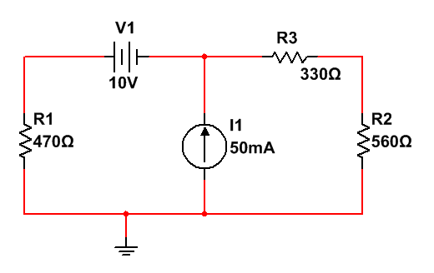

**Find:**

1. The current that flows through R3 due only to the 10V source and the direction of this current
2. The total current that flows through R3 and the direction of this current

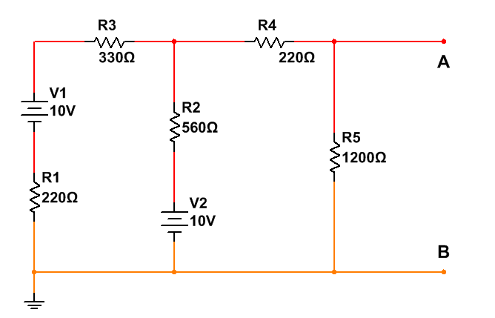

**Find:**

1. The Thevenin equivalent resistance (RTH) looking back into the circuit from terminals A-B (the load has already been removed)
2. The Thevenin equivalent voltage (VTH) looking back into the circuit from terminals A-B (the load has already been removed)
3. The power dissipated by a 100 Ohm resistor placed between terminals A-B